Task 1: Search Engine Results Comparison
Search Query: “best budget smartphones 2024”
I searched for “best budget smartphones 2024” on Google, Bing, and DuckDuckGo. I compared the first three results shown by each search engine.

1: Google search results :-

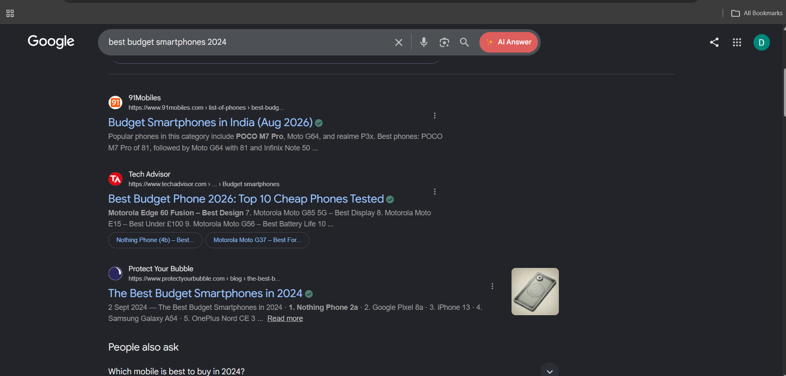
2: Bing search results :-
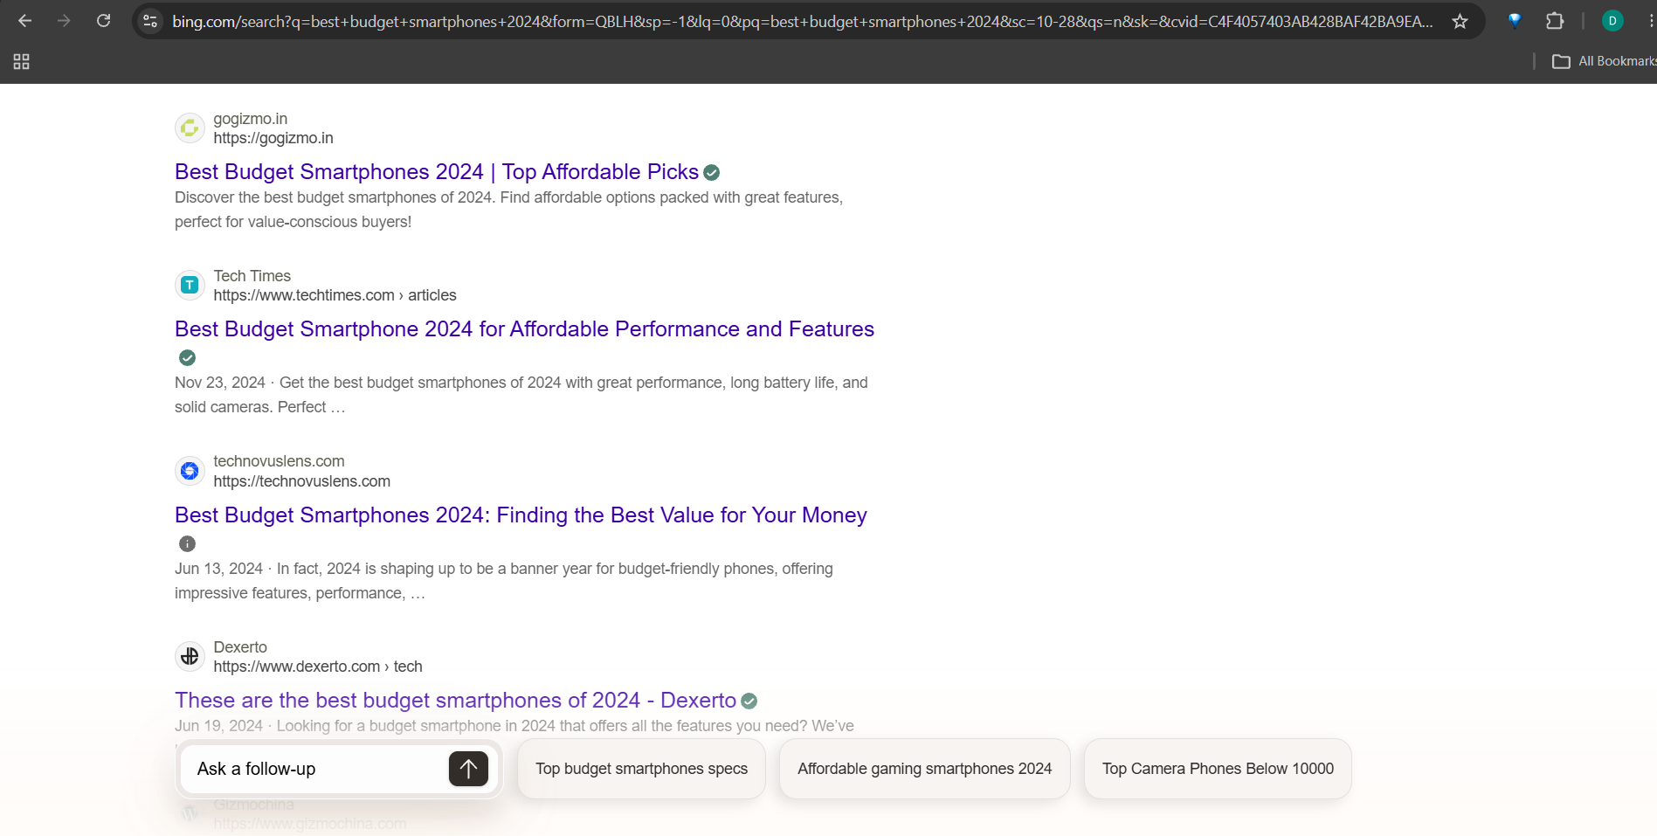
3: DuckDuckGo search results :-
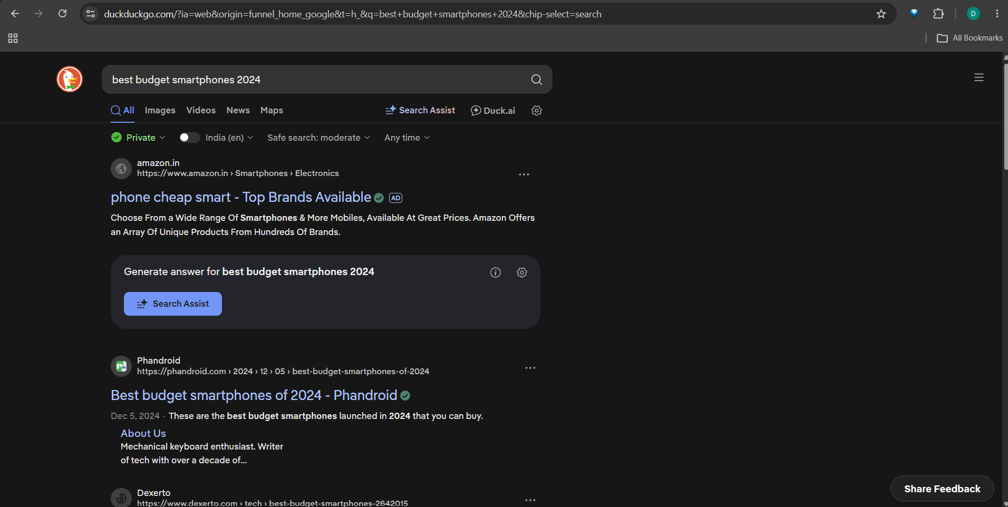

Search Engine | 1st Result | 2nd Result | 3rd Result
Google | Budget Smartphones in India (Aug 2026) – 91mobiles | Best Budget Phone 2026: Top 10 Cheap Phones Tested – Tech Advisor | The Best Budget Smartphones in 2024 – Protect Your Bubble
Bing | Best Budget Smartphones 2024 | Top Affordable Picks – Gogizmo.in | Best Budget Smartphone 2024 for Affordable Performance and Features – Tech Times | Best Budget Smartphones 2024: Finding the Best Value for Your Money – Technovuslens.com
DuckDuckGo | phone cheap smart – Top Brands Available – Amazon.in (Ad) | Best budget smartphones of 2024 – Phandroid | These are the best budget smartphones of 2024 – Dexerto
Differences Observed
The results were different on all three search engines. Google showed results from 91mobiles, Tech Advisor, and Protect Your Bubble. Bing showed Gogizmo.in, Tech Times, and Technovuslens.com. DuckDuckGo showed an Amazon advertisement first, followed by Phandroid and Dexerto. The order and websites were different because each search engine uses its own search algorithm to rank results.

Task 2: Search Engine Comparison Table

5 Popular Search Engines and Their Unique Features
No. | Search Engine | Unique Feature / Why a User Might Choose It
1 | Google | Provides very fast and highly relevant search results and has many useful features such as Maps, Images, News, and Google Scholar.
2 | Bing | Offers strong image and video search features and integrates well with Microsoft products such as Windows and Edge.
3 | DuckDuckGo | Focuses on privacy and does not track users in the same way as many mainstream search engines.
4 | Yahoo | Provides search along with other services such as Yahoo Mail, News, Finance, and Sports in one place.
5 | Baidu | A popular search engine in China, offering services and results that are especially useful for Chinese-language searches.
Short Conclusion
There are many search engines available, and each one has different features. Google is popular for its accurate and wide range of search services, while Bing is useful for Microsoft users. DuckDuckGo is a good choice for people who value privacy. Yahoo combines search with several other online services, while Baidu is particularly useful for Chinese-language information.
Task 3: Organic Results vs. Paid Results

Difference Between Organic and Paid Search Results
Organic results are webpages that appear naturally on a Google search results page because Google considers them relevant and useful for the search. Paid results are advertisements that businesses pay Google to display, usually near the top of the results page. Paid results are identified with labels such as “Sponsored” or “Ad.” For example, in my search for “best budget smartphones 2024” on DuckDuckGo, the Amazon result was marked “AD,” making it a paid result. The Phandroid result below it did not have an ad label, so it was an organic result.
Simple difference
Organic = Earned through search ranking
Paid = Advertiser pays for placement
Task 4: Google Search Process Flowchart

Google Search Process
┌───────────────┐
│ CRAWLING │
│ │
│ Google bots │
│ discover and │
│ visit web │
│ pages. │
└───────┬───────┘
↓
┌───────────────┐
│ INDEXING │
│ │
│ Google analyzes│
│ and stores │
│ information │
│ about pages. │
└───────┬───────┘
↓
┌───────────────┐
│ RANKING │
│ │
│ Google decides │
│ which relevant │
│ pages should │
│ appear first. │
└───────────────┘
1. Crawling 🕷️
Google uses automated programs called crawlers or Googlebots to discover and visit webpages. They follow links to find new and updated content.
↓
2. Indexing 📚
Google analyzes the information found on webpages and stores useful information in its search index. This helps Google find relevant pages when someone searches.
↓
3. Ranking 🏆
When a user searches for something, Google's systems evaluate relevant pages and order them based on factors such as relevance, quality, usefulness, and other signals.

Task 5: Trending Topic – Samsung Galaxy S26 FE
Trending Topic: Samsung Galaxy S26 FE
I selected the Samsung Galaxy S26 FE as my trending topic because it is a new smartphone. I searched for “Samsung Galaxy S26 FE” on Google and examined the first page of search results.
I found organic results such as Samsung Newsroom and 91mobiles. These results appeared as normal search listings without an “Ad” or “Sponsored” label. Organic results appear because Google considers the webpages relevant to the user's search.
In my search, Google did not show any clearly labelled paid advertisements on the first page. Therefore, I could not identify two paid results. Paid results are normally easy to recognize because Google labels them “Sponsored” or “Ad” and they may appear above or among the organic results.
Results
Type | Result | How I recognized it
Organic Result 1 | Samsung Newsroom – Samsung Galaxy S26 FE | No “Ad” or “Sponsored” label
Organic Result 2 | 91mobiles – Samsung Galaxy S26 FE | No “Ad” or “Sponsored” label
Paid Result 1 | No paid result displayed | No “Ad” or “Sponsored” result was visible
Paid Result 2 | No paid result displayed | No “Ad” or “Sponsored” result was visible
Conclusion
This search helped me understand the difference between organic and paid search results. Organic results appear naturally according to Google's ranking system, while paid results are advertisements purchased by businesses. Paid results are identified by labels such as “Ad” or “Sponsored.” In my search for “Samsung Galaxy S26 FE,” no paid advertisements were displayed on the first page, so I could only identify organic results.

Task 5: Identify Organic and Paid Results
Trending Topic: Samsung Galaxy S26 FE
I selected Samsung Galaxy S26 FE as my trending topic. I searched for “Samsung Galaxy S26 FE” on Google and examined the first page of search results.
Results
Type | Search Result | How I identified it
Organic Result 1 | Samsung Galaxy S26 FE in for review – GSMArena.com | No “Ad” or “Sponsored” label
Organic Result 2 | Introducing Galaxy S26 FE | Galaxy AI | Samsung – YouTube | No “Ad” or “Sponsored” label
Paid Result 1 | No paid result displayed | No “Ad” or “Sponsored” label was visible
Paid Result 2 | No paid result displayed | No “Ad” or “Sponsored” label was visible
Explanation
I recognized the organic results because they appeared as normal search listings without an “Ad” or “Sponsored” label. The first result was from GSMArena and the second was a Samsung YouTube video. In my search, Google did not display any clearly labelled paid advertisements on the visible first page, so I could not identify two paid results.
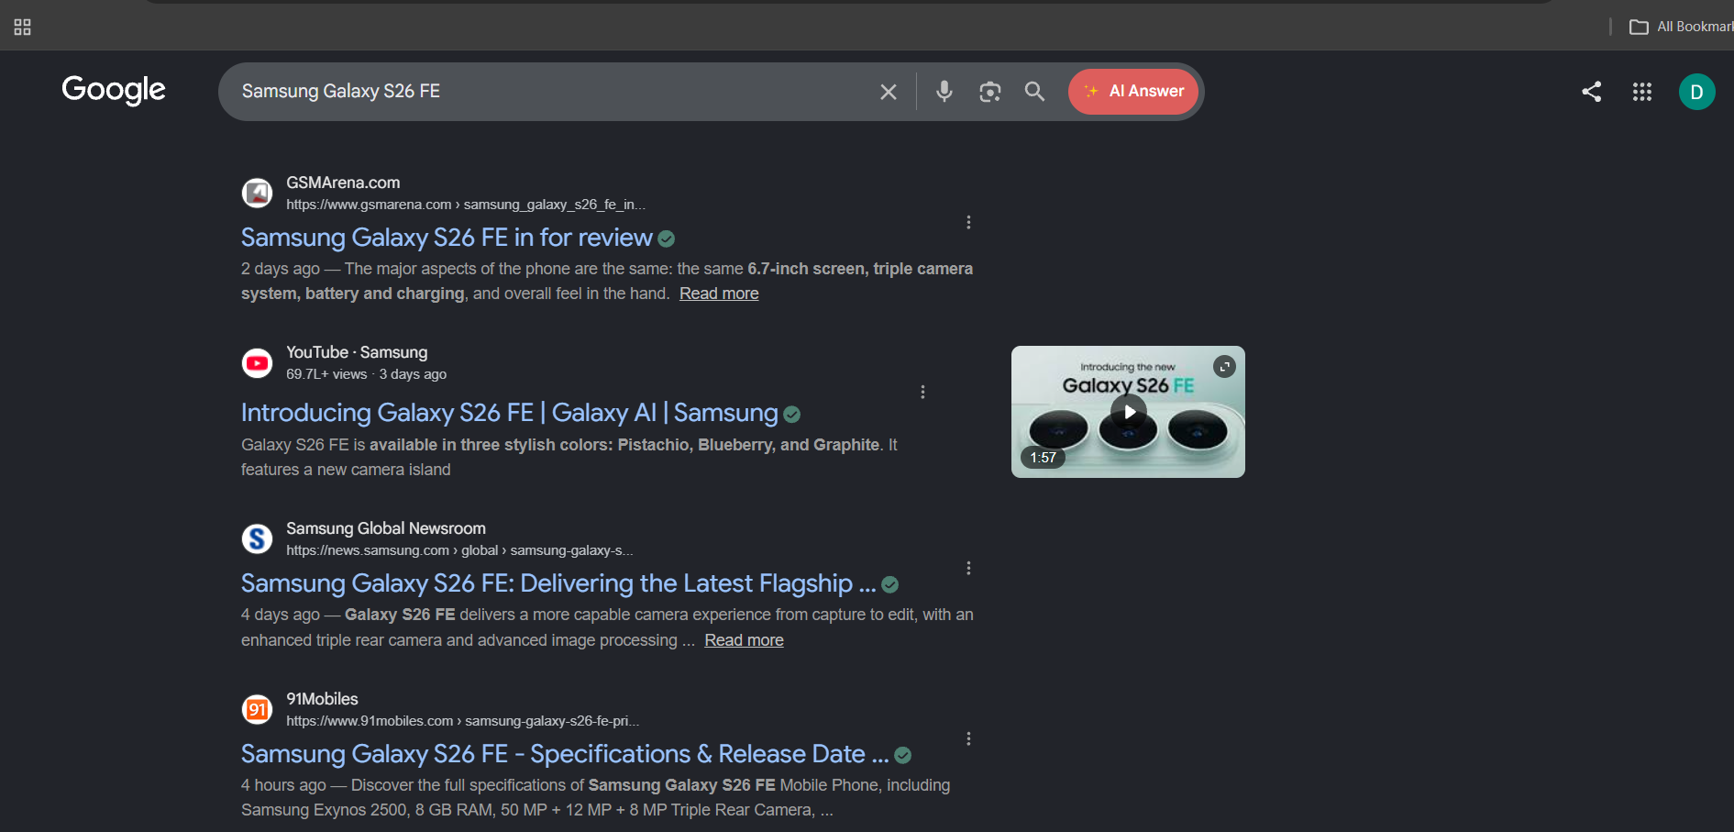
Conclusion
This search showed me that Google displays organic results based on their relevance to the search query. Paid results are normally identified by labels such as “Ad” or “Sponsored.” In my search for “Samsung Galaxy S26 FE,” I did not see any paid results, so I identified the normal listings as organic results. This demonstrates that paid advertisements are not necessarily displayed for every search.

